**SMTP Sampler script:**

In test plan-right click-add-thread –thread group

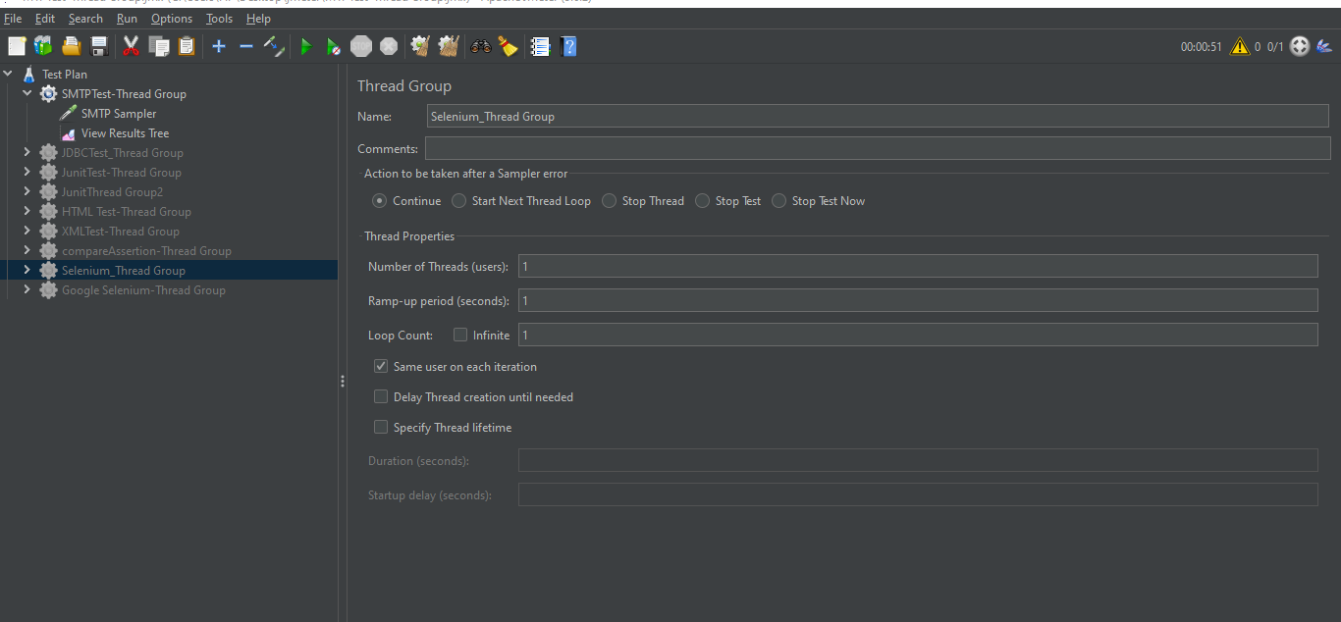

Thread group –right click-sampler-Smtp request

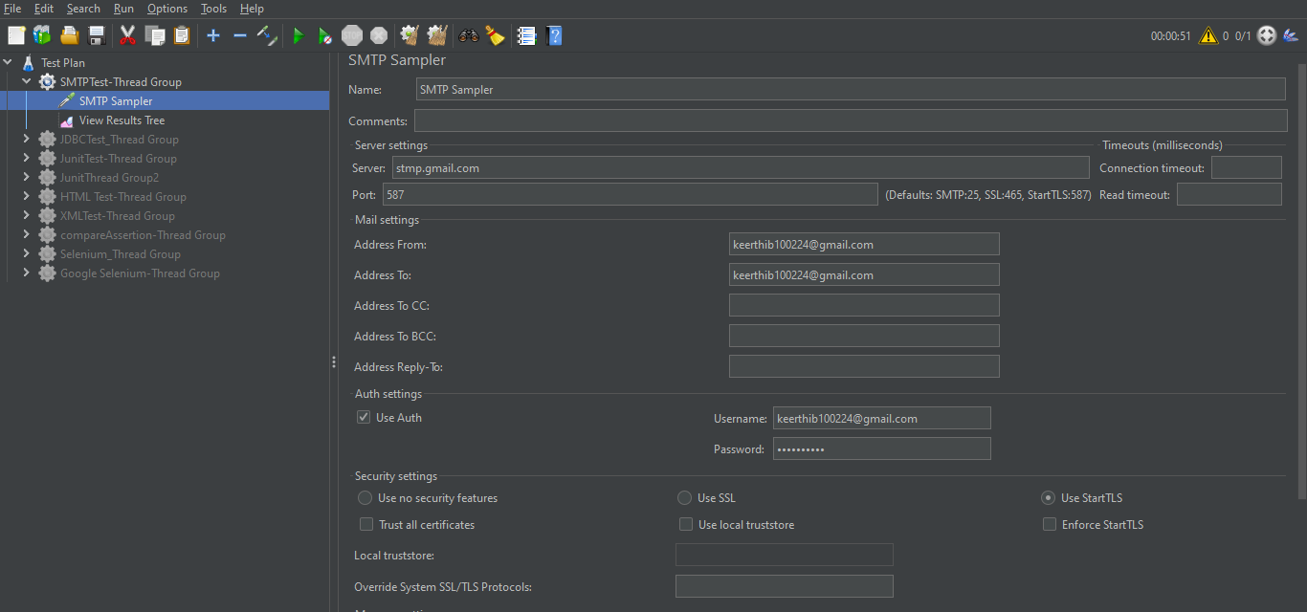

Enter email id and password .

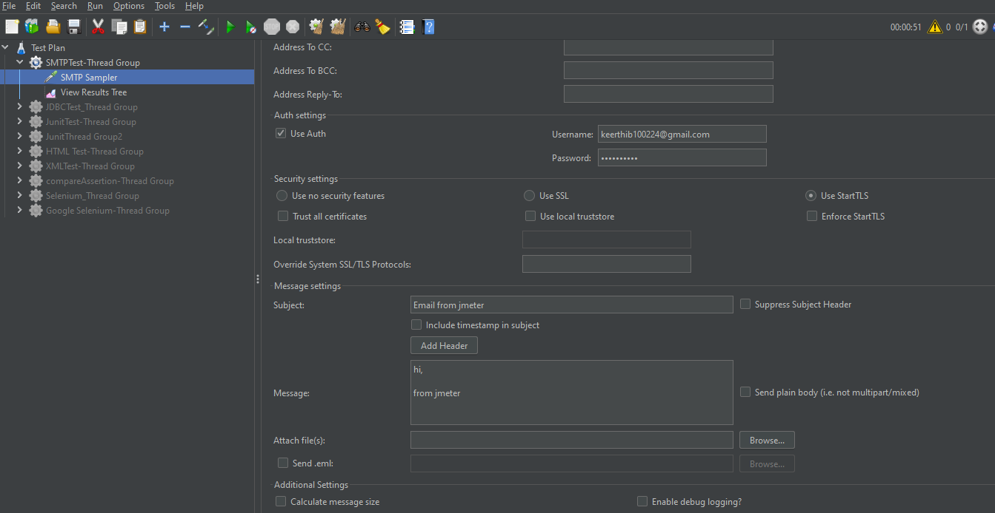

Thread group-right click-add-listener-view result tree

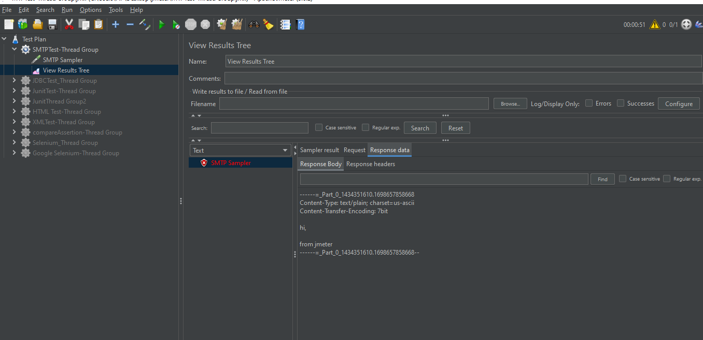

Execute the Sampler. The request will fail as username and password is incorrect.

Because gmail SMTP server is not allowing third party tools to use it and send emails.